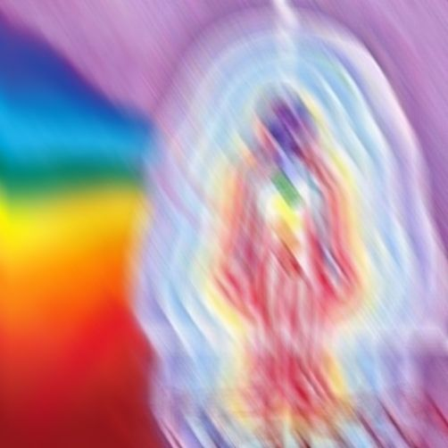
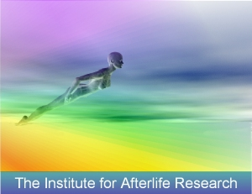
The Purpose
of
Physical Life

What is the Purpose of Physical Life?
Do we survive Death? Is there an Afterlife? How can we explore what will happen to us when we take the transition from this life into the next?

Our workshops examine the fascinating answers to these important questions in an inspiring manner that has no religious or theoretical bias.

As one participant recently wrote "Looking at the subject of life after death in such detail really does give you a wonderful appreciation of daily life and this incredible journey that we all share".

Two Day Workshop
This exciting workshop educates participants about the overwhelming evidence for the survival of physical death and the purpose of daily life.

This is conducted through Stimulating Lectures, Audiovisual Programs and Group Discussion.

The workshop also examines safe methods that can enable almost anyone to Explore the Afterlife and gain validity of the reality of their experiences.

Fascinating Topics Include
Near Death Experiences - Dr Raymond Moody, Typical Aspects of NDEs, Dannion Brinkley, Scientific Evidence

Evidence for Past Lives - Dr Ian Stevenson, Children’s Past Life Memories, Hypnotic Regressions, Verification

The Purpose of Physical Life - Spiritual Growth, Karma, Helping Others, Between Lives, Nature of Reality

Exploring the Afterlife - Out of Body Experiences, The Monroe Institute, Altering Consciousness using Sound, Map of the Afterlife, Safe Practical Exercise, Bruce Moen, ITC, Reunions with Departed Loved Ones

Do we Survive Physical Death?

So what exactly happens to us when we die? Is it the end? If not, then is there any way we can explore what happens to us as we take the transition from this life into the next? During this weekend workshop we will explore the fascinating answers to these important questions in a manner that has no religious or theoretical bias.

Two Day Workshop
Weekends 10:00am – 6:00pm
Tara, County Meath, Ireland

As Featured on Radio & TV:

the late late show
Ireland am (TV3)
the GERRY RYAN SHOW
(and numerous other radio programmes)

Overwhelming Evidence for Life After Death
Now, more than at any other time in history we have access to vast amounts of evidence for the eternity of life. You will learn about this exciting evidence from the experiences of thousands (and in some cases millions) of people from around the world. These experiences shed much light on the meaning of earthly life.

Near Death Experiences (NDEs)
Learn about the fascinating experiences of millions of people (of all religious persuasions) from around the world who have clinically died and then been resuscitated. Find out about Dannion Brinkley who died for 28 minutes in 1975 and was shown 117 Major World Events that would take place in the future. Almost all of these have now taken place. Why do those having NDEs feel it is so important to help others?

Evidence for Past Lives
Discover the evidence for Past Lives and the thousands of people who claim to remember them. Many of these people have checked up on their former lives through genealogical and historical records only to discover that the person who they claim to have been, really existed and lived and in the manner in which they remember. Amazingly, recent research also tells us that most small children have memories of a former lifetime. Once again, many of these past lives can be verified. Learn how to recognise the important cues that small children may give us about their past lives.

The Spiritual State After Death
Find out how numerous people under hypnosis can remember the “Spiritual State” experienced between physical lives where they plan their next physical lifetime according to what they need to learn. Look at the abundant evidence that suggests that parents, husbands, wives, brothers, sisters, aunts, uncles, friends and lovers return to physical life together again and again.

Exploring the Afterlife
Hear about people who actually explore the Afterlife on a daily basis and how you can also learn to do the same in an effective and safe manner. Learn why it is so important to be able to verify the reality of such experiences. Find out about the numerous research organisations around the world that teach ordinary people to explore the various regions of the Afterlife and gain tangible evidence for the continuance of life beyond physical death. Experience a “journey” for yourself!

Mapping the Afterlife
Learn about regions of the Afterlife where many reside after death. Discover some of the options available to those who have died.
Workshop fee: €195.00 (IR£153.00)
Register early! Space is limited!

For Further Details contact:
The Institute for Afterlife Research
Tara, County Meath, Ireland.

Tel: 046 26481 / 087 2078977
iar@mikepettigrew.com

For a wealth of information about Life After Death visit The Institute for Afterlife Research website at:
www.mikepettigrew.com/afterlife

The Purpose of Physical Life

an Institute for Afterlife Research Workshop
conducted by: Mike Pettigrew

“How powerful the fear of death is. People go to such great lengths to avoid the fear: mid-life crisis, affairs with younger people, cosmetic surgery, exercise obsessions, accumulating material possessions, procreating to carry on a name, striving to be more and more youthful, and so on. We are so frightfully concerned with our own deaths, we sometimes forget the purpose of our lives”
Dr Brian L Weiss

In 1977 Mike Pettigrew’s cousin died in a road accident. This tragic event led him to start asking questions like what is the purpose of physical life and what really happens when we die? During the 25 years he has been researching the answers to these crucially important questions he has met numerous people who have died for a number of minutes and then been resuscitated. Many of these people have experienced a profound state of consciousness during the period they were physically dead and report that they no longer have any fear of death. Mike has also been privileged to have personally learned from a number of famous authors (including Dannion Brinkley & Bruce Moen) who have explored the afterlife in great detail and brought back concrete information about life on “the other side”. He has also had numerous tangible experiences that have proved to him beyond any doubt that we all survive physical death.

Having qualified as an Electronic Engineer in 1985 followed by running a highly successful business for fifteen years, Mike Pettigrew founded The Institute for Afterlife Research in order to further research and teach the overwhelming evidence for the existence of life after death. He is also an experienced healer having trained in numerous forms of healing therapy. The primary aims of The Institute for Afterlife Research are to assist individuals in overcoming their fears of death and to discover a renewed sense of purpose in daily life.

A weekend of learning about the fascinating and abundant evidence for the eternity of life & it’s purpose through Lecture, Audiovisual Programs, Group Discussion & Practical Exercises.

Workshop Description
During this exciting two-day workshop participants will hear the fascinating experiences of people who have had encounters with the afterlife. It is highly suited to those seeking to gain a better understanding of the purpose of life as well as helping to reduce the fear of death.

Why Should I Attend this Workshop?
Participants have told us that this workshop not only proved to them that life will continue after their physical death, but that it has also enabled them to discover a greater sense of purpose and appreciation of their daily lives.

Examining the eternity of life in such detail can also enable us to understand the relevance of our day-to-day struggles and the preciousness of each moment of physical life. It can even stimulate us to examine our attitudes and revaluate our priorities in a fresh, powerful and dynamic way.

As a result of this workshop, one participant even decided to start doing voluntary work so he could contribute to other people’s happiness.

2003 Weekend Workshop Dates

18/19th January, 15/16th February, 22/23rd March, 12/13th April, 14/15th June, 16/17th August, 18/19th October, 6/7th December

Directions and details provided upon registration.

Additional workshops at Astral Plane, Co Carlow
19/20th July & 15/16th November

Cost
The full price for this workshop is €195.00
A 50% deposit is required at least two weeks before the workshop date. You may pay by International Money Order, Bank Draft or Irish Cheque.

Cancellation policy: Full refund if canceled two weeks prior to workshop date, 75% thereafter.

To attend a Workshop contact:
The Institute for Afterlife Research, Tara, County Meath, Ireland.
Tel: 353-(0)46-26481 or Mobile: (0)87-2078977 or email: iar@mikepettigrew.com

Additional workshops can be arranged for your group or society. Please note a minimum of ten participants will be required.

More information
To learn more about the overwhelming evidence for the survival of physical death, to listen to interviews, or to share your questions, views or experiences with others, please visit The Institute for Afterlife Research’s web site at: www.mikepettigrew.com/afterlife

